$$Linear regression assumptions$$

$$Every model made by some assumptions, if that assumptions are not validate$$

$$The model performance become less$$

$$Linear regression assumptions is divided into two ways$$

$Based on features or input columns$

$Based on Errors or Residuals$

$$Assumtions based input columns:$$

$Linearity:$

$There is a linear relationship between dependent and independent variable$

$Model name is Linear regression$

$it is an important property to maintain linear relationship$

$How to check:$

$Scatter plots are the best to identify the linear relationship$

$we cant draw more than 3D data$

$We want Linearity$

$Multicollinearity:$

$Input varaibles should be independent each other$

$If input columns having relation then this multicollineraity$

$Multicollineraity is similar to correlation$

$Any model:It is better to have input columns No Multicollinearity$

$We don^{'}twant Multicollinearity$

$How to check$

$Math analogy$

|  |  |  |
| --- | --- | --- |
| $$x_{1}$$ | $$x_{2}$$ | $$y=b_{o}+b_{1}*x_{1}+b_{2}*x_{2}$$ |
| 2 | 4 |  |
| 4 | 8 |  |
| 6 | 12 |  |
| 8 | 16 |  |

$$x_{1} and x_{2} both are dependent : x_{2}=2*x_{1}$$

$$y=b_{o}+b_{1}*x_{1}+b_{2}*2x_{1}$$

$$y=b_{o}+x_{1}[b_{1}+2b_{2}]$$

$b_{1}+2b_{2}=0$

$maths says, if you want find two unknows we need two equations$

$but above we have one equation and two unknowns :Maths fail$

$$VIF:Variance inflation factor$$

$$VIF will give which variable cause the multicollineraity$$

$VIF=\frac{1}{1-R_{square}}$

$$Procedure:$$

$we already know what is R_{Square}$

$$R_{square}: Explanibility$$

$How much input varaible explaianing about variance in output variable$

$$Assume that we have 3 input columns are there:x_{1},x_{2},x_{3}$$

$Y=b_{o}+b_{1}*x_{1}+b_{2}*x_{2}+b_{3}*x_{3}$

$$Main goal :Idenrify the Multicollineraity between input columns$$

$For that we need to calculate VIF value$

$VIF value depends on R_{square} value$

$$Step-1: Consider x_{1} as output variable ,$$

$$x_{2} and x_{3} consider as input$$

$x_{1}=b_{o}+b_{2}*x_{2}+b_{3}*x_{3}$

$the above equation will give R_{square}$

$R_{square} will give VIF value$

$assume: R_{square}=0.9 VIF=\frac{1}{1-0.9}=\frac{1}{0.1}=10$

$$Step-2: Consider x_{2} as output variable ,$$

$$x_{1} and x_{3} consider as input$$

$x_{2}=b_{o}+b_{1}*x_{1}+b_{3}*x_{3}$

$the above equation will give R_{square}$

$R_{square} will give VIF value$

$R_{square}=0.95 VIF=\frac{1}{1-0.95}=\frac{1}{0.05}=20$

$$Step-3: Consider x_{3} as output variable ,$$

$$x_{1} and x_{2} consider as input$$

$x_{3}=b_{o}+b_{1}*x_{1}+b_{2}*x_{2}$

$the above equation will give R_{square}$

$R_{square}=0.80 VIF=\frac{1}{1-0.8}=\frac{1}{0.2}=5$

$$Conclusion:$$

$$In industry VIF>10 we can consider as Multicollineraity is there$$

$$x_{2} gives VIF=20 , so x_{2} has more multicollineraity with x_{1} and x_{3}$$

$$we will not consider x_{2} for model development$$

$Remove the variables$

$PCA:Principle component analysis$

$$So Multicolineraity concept also used as Feature selection$$

$$Till now the Feature selection methods are$$

$$1) p-value$$

$$2) Adj R_Square$$

$$3) VIF$$

$$Assumtions based on Errors or Residuals:$$

$NO Autocorrelation$

$Means errors are not correlated each other$

$Homoscedasticity:$

$$The variace of errors is same across all independent varaiables$$

$variance should be constant$

$Errors Follows Normality$

$$The distribution of errors follows Normal distribution$$

$$NO Autocorrelation$$

$$Imagin that we have a data of 10 observations$$

$$each 10 observations we have 10 actual output$$

$$10 observations we pass to model , then model will give 10 prediction$$

$$we will get 10 errors$$

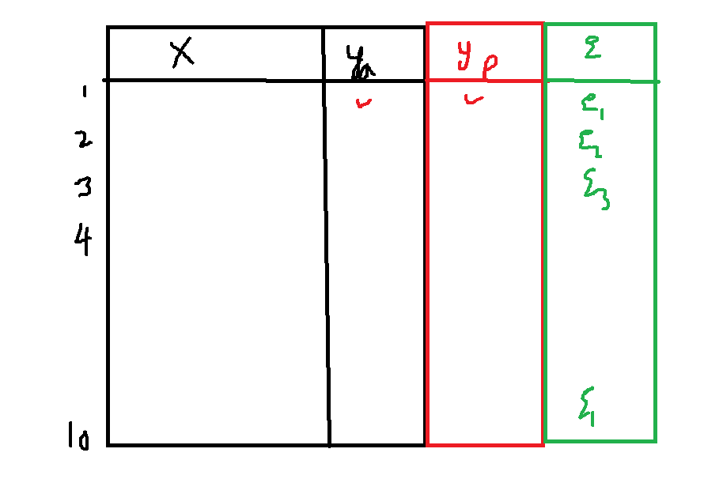

$$Auto correlation:$$

$$Finding the relation between the values of same column$$

$$Errors should not have autocorrelation$$

$$How to check:$$

$$Durbon watson test\left(DW test\right)$$

$$e_{1}, e_{2},e_{3},e_{4},……e_{n}$$

$$Step-1: Difference between the errors$$

$d_{1}=e_{2}-e_{1}$

$$d_{2}=e_{3}-e_{2}$$

$$d_{3}=e_{4}-e_{3}$$

$$d_{t}=e_{t+1}-e_{t}$$

$$Nr=summation of difference of errors squares$$

= $d_{1}^{2}+d_{2}^{2}+d_{3}^{3}+…+d_{t}^{2}=$

$${(e}_{2}-e_{1})^2 +(e_{3}-e_{2})^2+….(e_{t+1}-e_{t})^2$$

$$Dr=sum of square of errors$$

$$DW=\frac{\sum_{t=2}^{n}{{\left(e_{t}-ⅇ_{t-1}\right)}^{2}}}{\sum_{t=1}^{n}{ⅇ_{t}^{2}}}$$

|  |  |  |  |
| --- | --- | --- | --- |
| $$x$$ | $$y$$ | $$y_{p}=-2.6268x+1,129.2$$ | $$error=(y_{a}-y_{p})$$ |
| 10 | 1100 | $$-2.6268*10+1,129.2=1102.9$$ | $$-2.9$$ |
| 20 | 1200 | $$-2.6268*20+1,129.2=1076.7$$ | $$123.3$$ |
| 35 | 985 | $$-2.6268*35+1,129.2=1037.3$$ | $$-52.3$$ |
| 40 | 750 | $$-2.6268*40+1,129.2=1024.1$$ | $$-274.1$$ |
| 50 | 1215 | $$-2.6268*50+1,129.2=997.8$$ | $$217.1$$ |
| 451 | 1000 | $$-2.6268*45+1,129.2=1011$$ | $$-11$$ |

$$DR=sum of square errors$$

$$e_{1}^{2}+e_{2}^{2}+e_{3}^{2}+e_{4}^{2}+e_{5}^{2}+e_{6}^{2}$$

$${\left(-2.9\right)}^{2}+{\left(123.3\right)}^{2}+{\left(-52.3\right)}^{2}+{\left(-274.1\right)}^{2}+{\left(217.1\right)}^{2}+{\left(-11\right)}^{2}=140,330.81$$

$$Nr=Difference of errors$$

$$d_{1}^{2}={\left(e_{2-}e_{1}\right)}^{2}={\left(126.2\right)}^{2}$$

$$d_{2}^{2}={(e}_{3-}e_{2})^2=(-175.6)^2$$

$$d_{3}^{2}={(e}_{4-}e_{3})^2 =(-221.9)^2$$

$$d_{4}^{2}={\left(e_{5-}e_{4}\right)}^{2}={\left(491.3\right)}^{2}$$

$$d_{5}^{2}={(e}_{6-}e_{5})^2 =(-228.1)^2$$

$${\left(126.2\right)}^{2}+{\left(-175.6\right)}^{2}+{\left(-221.9\right)}^{2}+{\left(491.3\right)}^{2}+{\left(-228.1\right)}^{2}=389,406.71$$

$$DW=\frac{\sum_{t=2}^{n}{{\left(e_{t}-ⅇ_{t-1}\right)}^{2}}}{\sum_{t=1}^{n}{ⅇ_{t}^{2}}}=\frac{389,406.71}{140,330.81}=2.77$$

$$Dw test interpretation:$$

$$Ranges 0 to 4$$

$$DW= 0 to 2 : Negative relation$$

$$Dw=2 : No relation$$

$$DW=2 to 4: Postive relation$$

$$Homoscedasticity :$$

$Errors have constant variance throughout the data$

$Constant variance means homoscedasticity$

$The distribution of errors is constant$

$$Heteroscedasticity :$$

$Errors have not constant variance(tunnel shape) throughout the data$

$No Constant variance means heterooscedasticity$

$The distribution of errors is not constant$

$$How to check:$$

$$Residuals vs Fitted plot$$

$$Errors vs Predictions$$

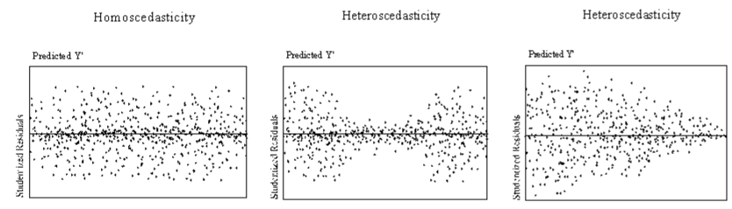

$$Normality:$$

$Errors should follow Normal distribution$

$$How to check:$$

$$Q-Q plot :Quantile-Quantile plot$$

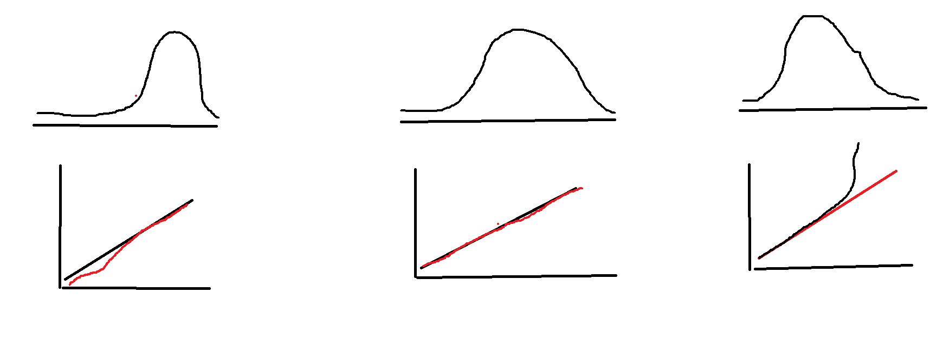

$$All together$$

$$1) Linearity : we want Linarity between input and output$$

$Scatter plot$

$$2) No Multicollinearity :we dont want multicolloniearity between input columns$$

$VIF$

$$3) No autocorrelation: We dont want relation between errors$$

$Dw test$

$$4) Homoscedasticity: we want constant variance of errors$$

$Residual vs fitted value or Errors vs Prediction$

$$5) Normality: we want error follows Normal distribution$$

$QQplot$